JU Ming (1938-)
JU Ming, also known as Ju Chuantai, is one the most prominent Taiwanese sculptors to have emerged in the later half of the 20th century. Born in Miaoli County in Northern Taiwan, he originally trained in wood sculpture, carving traditional figures such as those of the Buddha and Mazu, the sea goddess. In 1968, he decided to shift his focus to the depiction of modern themes. He studied with the famous sculptor Yang Yuyu, who suggested he change his name from Ju Chuangtai to Ju Ming to signify this change in artistic direction. Ju’s early works explored aspects of Taiwanese folk life, often depicting farmers, domestic animals or oxcarts. His geometric and abstract style of artistic execution was often compared to the vivid and expressive Xieyi (寫意) brush technique in Chinese ink-wash painting. His works were also praised for their ability to combine Chinese folk culture and artistic traditions with modern sensibilities. He attracted great attention from both the public and critics at his first solo show at National Museum of History in 1976. In 1971, following the expulsion of the ROC from the United Nations, his works were seen as representing Taiwan’s artistic spirit and its nativist cultural movement.

Ju’s work In One Heart (同心協力, 1976), depicting a hard-working farmer and his ox struggling to move forward in muddy soil, represented the difficult situation in which Taiwanese society found itself at that time, and encouraged its people to work together to tackle the problems relating to this loss of international political recognition.

Ju’s Taichi Series (太極系列, 1976-77) involved a number of works inspired by the Chinese martial art and became his most recognized works both nationally and internationally. In 1977, he exhibited at the Tokyo Central Art Museum, before travelling to New York in 1980, to pursue his studies in modern art. Here he developed a new style described as the Living World Series (人間系列, 1980-) that described the life styles of modern people in a humorous and colorful way.
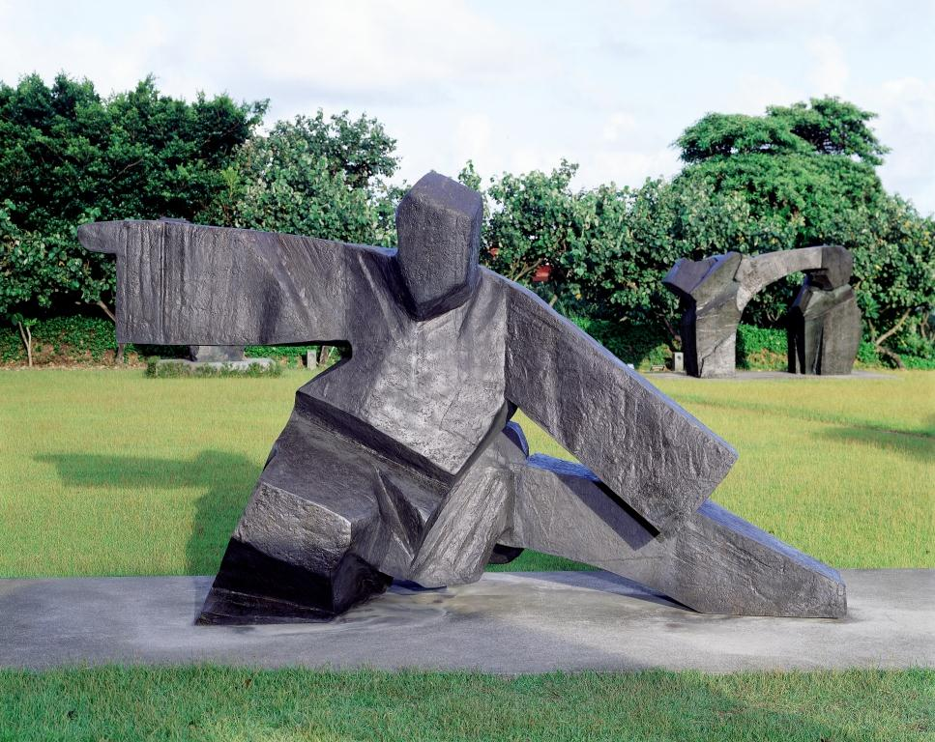
Ju Ming (朱銘), Taichi Series- Single Whip (太極系列-單鞭下勢), 1986, bronze, 467×188×267 cm

Ju has been invited to exhibit his works in Tokyo, Hong Kong, Manila, Bangkok, Singapore, New York, London, Paris, Yokohama, Luxembourg, Brussels, Yorkshire, Berlin, Macau, Beijing, and Montreal. He was awarded the Fok Ying Tung Award from the Fok Ying Tung Foundation (1998), the Honorary Degree of Doctor of Art from the Fu Jen Catholic University, Taipei (2003), the Executive Yuan Cultural Award (2004), as well as the 18th Fukuoka Asian Culture Prize, Art and Cultures Prize (2007). In 2011, he was also awarded the degree of Doctor of Literature, honoris causa, from the Chinese University of Hong Kong.

Useful Links
Ju Ming Museum, Biography.
http://www.juming.org.tw/opencms/juming_en/about/founder/lifed/lifed_0000.html?ts=1387123036620&info1=3&info2=1&tools=lifed&ina=2&seq=1

References and Further Reading
Huang, Yung-Sung. (1975) “Ju Ming, Wood Carver”, ECHO Magazine 5(10): 12-18.

Sullivan, Michael. (2005) “The Chinese Art of Sculpture and the Contribution of Ju Ming”, Ju Ming in Contemporary Vision. Taipei: Ju Ming Museum, 149-154.

Yu, Ta-kan. (1975) “Beyond Craft to Art”, ECHO Magazine 5(10): 18-26.

